CANDIDATE FOR: Vice President, Trustee

NAME: James A. Zwiebel |  | MILITARY RANK: MSgt
CURRENT OFFICE: Chapter President |  | CHAPTER ASSIGNED:1163
- AFSA ACTIVITIES
2020 – Treasurer Chapter 1163
2020 – Utah’s POW/MIA Remembrance Week – Committee Lead - Oversaw Revile kick-off, 24hr Run, Wreath Laying, Taps, National League Speakers events/ceremonies, and got 22 AFSA volunteers coined by 75 ABW/CC
2020 – DECA Shelf Stocking Team – Volunteer - Worked night shift, aid’d 400% shelf-stocking increase during COVID-19 surge
2020 – Giftwrapping Booth – Oversaw/Volunteered – Volunteered 16 hrs/Appointed 2 cmte leads coordinating 5 vol days
2020 – Angle Tree – lead – Coordinated donation of $300 to bases Angle Tree efforts
2020 – Toys-for-tots Collection site – Oversaw – Collected toys from 4 sites and coord’d 4 volunteers for packing
2020 – Elementary “Christmas Shopping” Parter – Oversaw – Partnered w/PTA volunteers assist student w/holiday shopping
2020 – SNCO PES – Briefer/Recruiter - Garnered 15 yearly and 4 life-time memberships
2020 – 5K Diversity Run - Committee Member - Coordinated run/booth for 150+ to support our “stronger together” culture shift
2020 – Golf Tournament – Finance Manager - Managed $22K in expenditure and $4.6K profit expense account for three orgs
2020 – Airman’s Council Development Plan – Advisor - Sat down with “First 4” Professional Org and advised
2020 – Chief’s Panel – Technical Support - Coordinated Zoom speaker, questions, and awards
2020 – International Legislation Week – Briefer - Manned 2 BX booths informing base of AFSA lobbyist actions
2020 – FTAC – Briefer/Recruiter - Communicated AFSA missioned to post COVID-19 FTAC, #1 in Div 6 Recruiting
2020 – President Chapter 1163
2021 – FW/CCC Professional Dvlpmnt – Oversaw/Technical Spt– Appointed Prof Dvlpmnt Coord’r/livestreamed to Facebook
2021 – State Park Building Proj – Volunteer – Dedicated 4hrs building buffalo fences w/14 Amn/NCOs/Retirees/Family members
2021 – POW/MIA Patch Project - Lead – Received ABW uniform ETP, purchased 1000 patches, Appt’d cmte, est. 14 BX booths
2021 – Membership Drive – Requester/Oversaw – Implemented Chapter level Recruiting incentives 130 recruiting hours mng’d
2021 – Trained 72 Unit POCs – Created recruiter/activities/legislation/History training team
2021 – Established 72 AFSA Unit POCs – Coordinator - Utilized 1st Sgt’s Council to est. POCs in every base/tenant unit
2021 – Chapter level Annual Awards – Dedicated 40hrs to Ch.’s annual packages as writer, est. 8 mbr Murder Board
2021 – Quarterly Awards – Presenter – Presented 2 OTQ awards along-side Amn’s Sq/CCs
- BASE & LOCAL COMMUNITY ACTIVITES
2018 – Toys for smiles – Gp’s Coordinator
2019 – Battered Women’s Shelter Renovation – Team Leader
- EDUCATION
A.S. Human Resource Management - 2016
A.S. Biomedical Equipment technology – 2018
B.S. Organization Management – in progress
- MILITARY SERVICE/EMPLOYMENT
2008-2016: Biomedical Equipment NCOIC, Nellis/Seymour Johnson AFB
2015: Airman Leadership School, Nellis AFB, NV – Distinguished Graduate
2016: Recruiting Student, Lackland AFB, TX – Top Graduate
2016-2017: Recruiter, 339th RCS, Mt. Pleasant, MI – Rookie of the Year, Flight’s Top Recruiter OTY, etc.
2017-2018: Special Operations Recruiter, 330th RCS, Mt. Pleasant, MI
2018-2019: Health Professions Recruiter, 362nd RCS, Phoenix, AZ – Gold Badge, Gp’s Top Medical Officer Recruiter OTY, AF’s Top Physician Recruiter OTY, Gp’s Top Biomedical Recruiter OTY, Gq’s Top Recruiter OTQ, etc.
2018: Non-Commissioned Officer School – Lackland AFB, TX – Distinguished Graduate
2019-2020: Officer Accessions Recruiter, 348th RCS, Clearfield, UT – Gp’s Top Recruiter OTQ, Gp’s Top Recruiting Flight X2, Gp’s Top Residency Physician Recruiter OTY, Gp’s Top Med Services Recruiter OTY, Gp’s Sijan Nominee, Chapter’s Exemplarary Member OTY, etc.
- FRATERNAL ACTIVITIES
Air Force Sergeants Association - Member for Life
DATE:  20210308 | ADDRESS:  1785 E. 1450 S. Suite 330  Clearfield, UT 84015 |  | SIGNATURE:

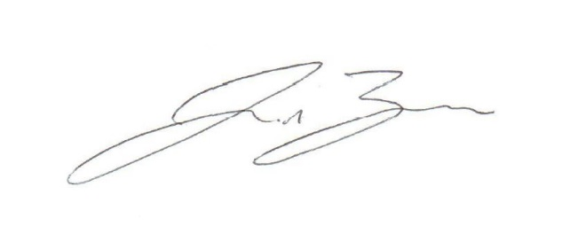
AFSA Form 100-10E, January 2007 Substitute Forms Not Acceptable

